41.52: a) Apply Coulomb’s law to the orbiting electron and set it equal to the centripetal force. There is an attractive force with charge +2e a distance r away and a repulsive force a distance 2r away. So,
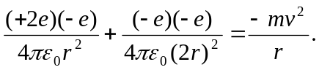
But, from the quantization of angular momentum in the first Bohr orbit, 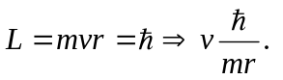
So 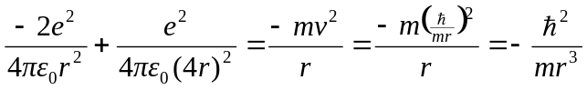
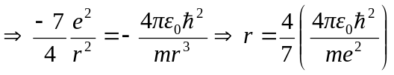
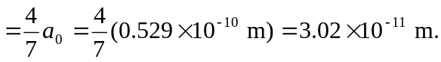

And 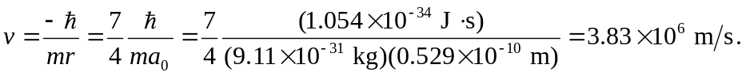
b)
c) 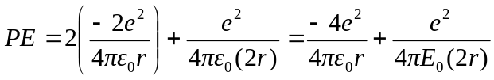 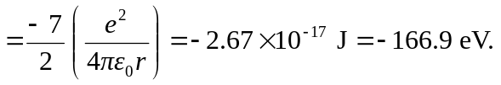
d) which is only off by about 5% from the real value of 79.0 eV.

